MFE FORMWORK MR11 SYSTEM
Data Models
Version 1.0
Prepared for
MFE Formwork
Prepared by
MyIntellX project team
Date
21 October 2026
Status
Draft for client review

Document control
Item | Detail
Document | Data Models
System | MFE Formwork MR11 System, version 1.0
Document version | 1.0
Date | 21 October 2026
Status | Draft for client review
Based on | Repository izzatmyintellx05/MFE, branch main, commit 0cc8c36
Prepared for | MFE Formwork
Prepared by | MyIntellX project team
Intended readers | Client IT, developers, data analysts
Classification | Confidential, for client and vendor use only

Revision history
Version | Date | Description | Author
1.0 | 21 October 2026 | First issue for client review | MyIntellX project team

Contents
1. Introduction 4
2. Conventions used in this document 5
3. The workbook model 5
3.1 FortuneSheet, one worksheet 7
3.2 FortuneCell and CellValue, one cell 7
3.3 The Dispatch workbook 7
4. Database tables 8
5. Extracted rows, used while the MR11 is built 10
6. The MR11 run and its rows 11
6.1 An MR11 row 12
6.2 The source snapshot 14
7. API models 15
8. Browser state 16
8.1 Who is signed in (the Zustand store in src/store/auth.store.ts) 16
8.2 What the browser remembers in localStorage 16
9. The in-memory store on the server 17
10. Configuration models (server/config/mr11.config.ts) 17

1. Introduction
This document describes how the MR11 System structures its data. Data passes through six layers on its way from a department's Excel file to what the user's browser remembers, and each layer has its own shape. The sections below take them in that order and explain every field.
The full column-by-column data dictionary for the database, with data types, is in Appendix A of the System Architecture Document. This document focuses on how the pieces relate to one another and what the fields mean.
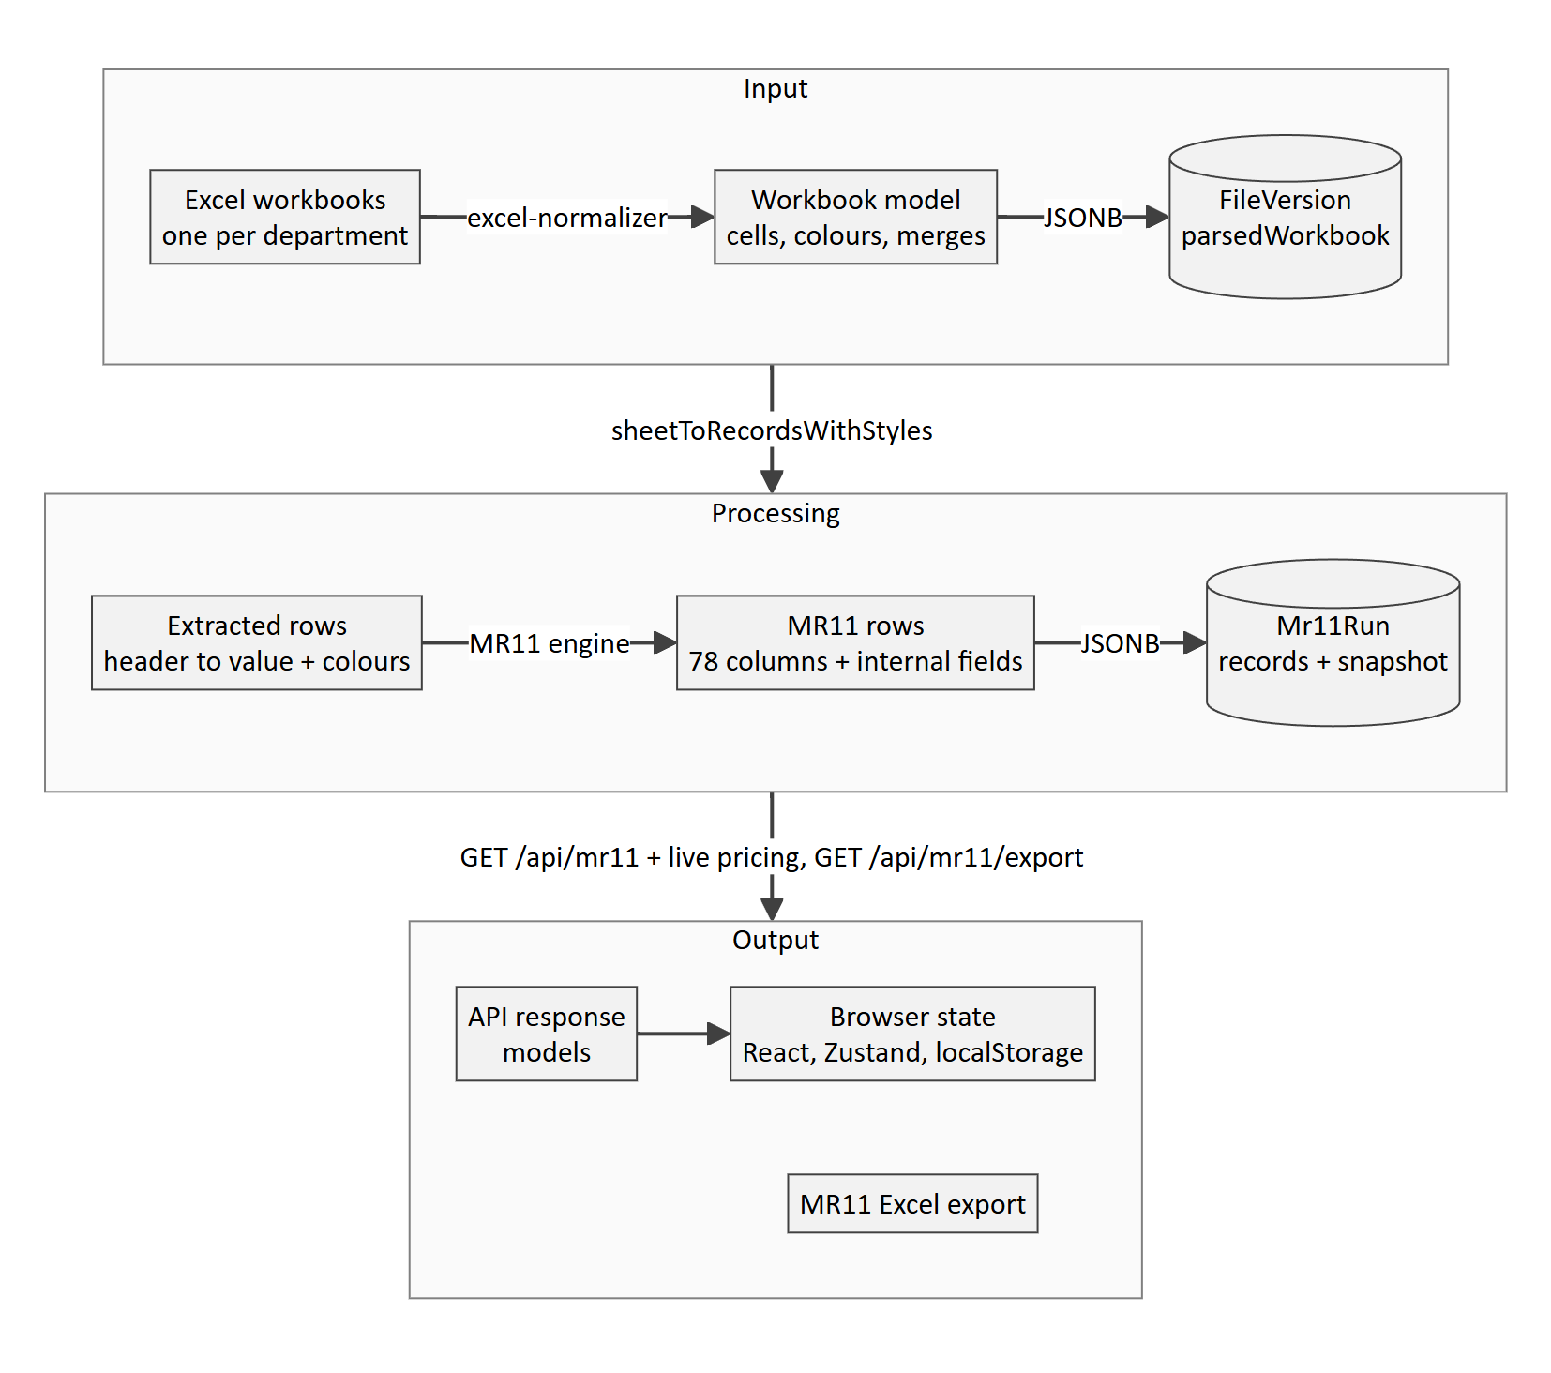
Figure 1: How data moves through the layers of the system
Layer | What it is | Where it lives | Section
Workbook model | Each uploaded sheet as cells, with their values, colours and merges | FileVersion.parsedWorkbook (JSONB) | 3
Database tables | Users, roles, departments, workbook versions and MR11 runs | Supabase PostgreSQL | 4
Extracted rows | A sheet's rows as header and value pairs, with each row's font and fill colour | Server memory, while an MR11 is being built | 5
MR11 run and rows | The finished schedule and the history it carries forward | Mr11Run (JSONB) | 6
API models | The JSON that the API sends and receives | HTTP requests and responses | 7
Browser state | Who is signed in, page settings and filters | React state, Zustand and localStorage | 8

2. Conventions used in this document
- Field names are written exactly as they appear in the code (camelCase), and MR11 column names as they appear on screen.
- Dates inside JSON are text in the form YYYY-MM-DD. Database timestamps are TIMESTAMP(3), which is accurate to the millisecond.
- Colours are hex text such as #FF9900, and an empty fill means the cell has no fill.
- Where we say "map", we mean a JSON object used as a lookup, such as one that gives the m² for each month.

3. The workbook model
When a workbook is uploaded, server/utils/excel-normalizer.ts turns each of its sheets into the structure below, and the department page draws the sheet back from it. Dispatch keeps its Local and Overseas files together in a single object.
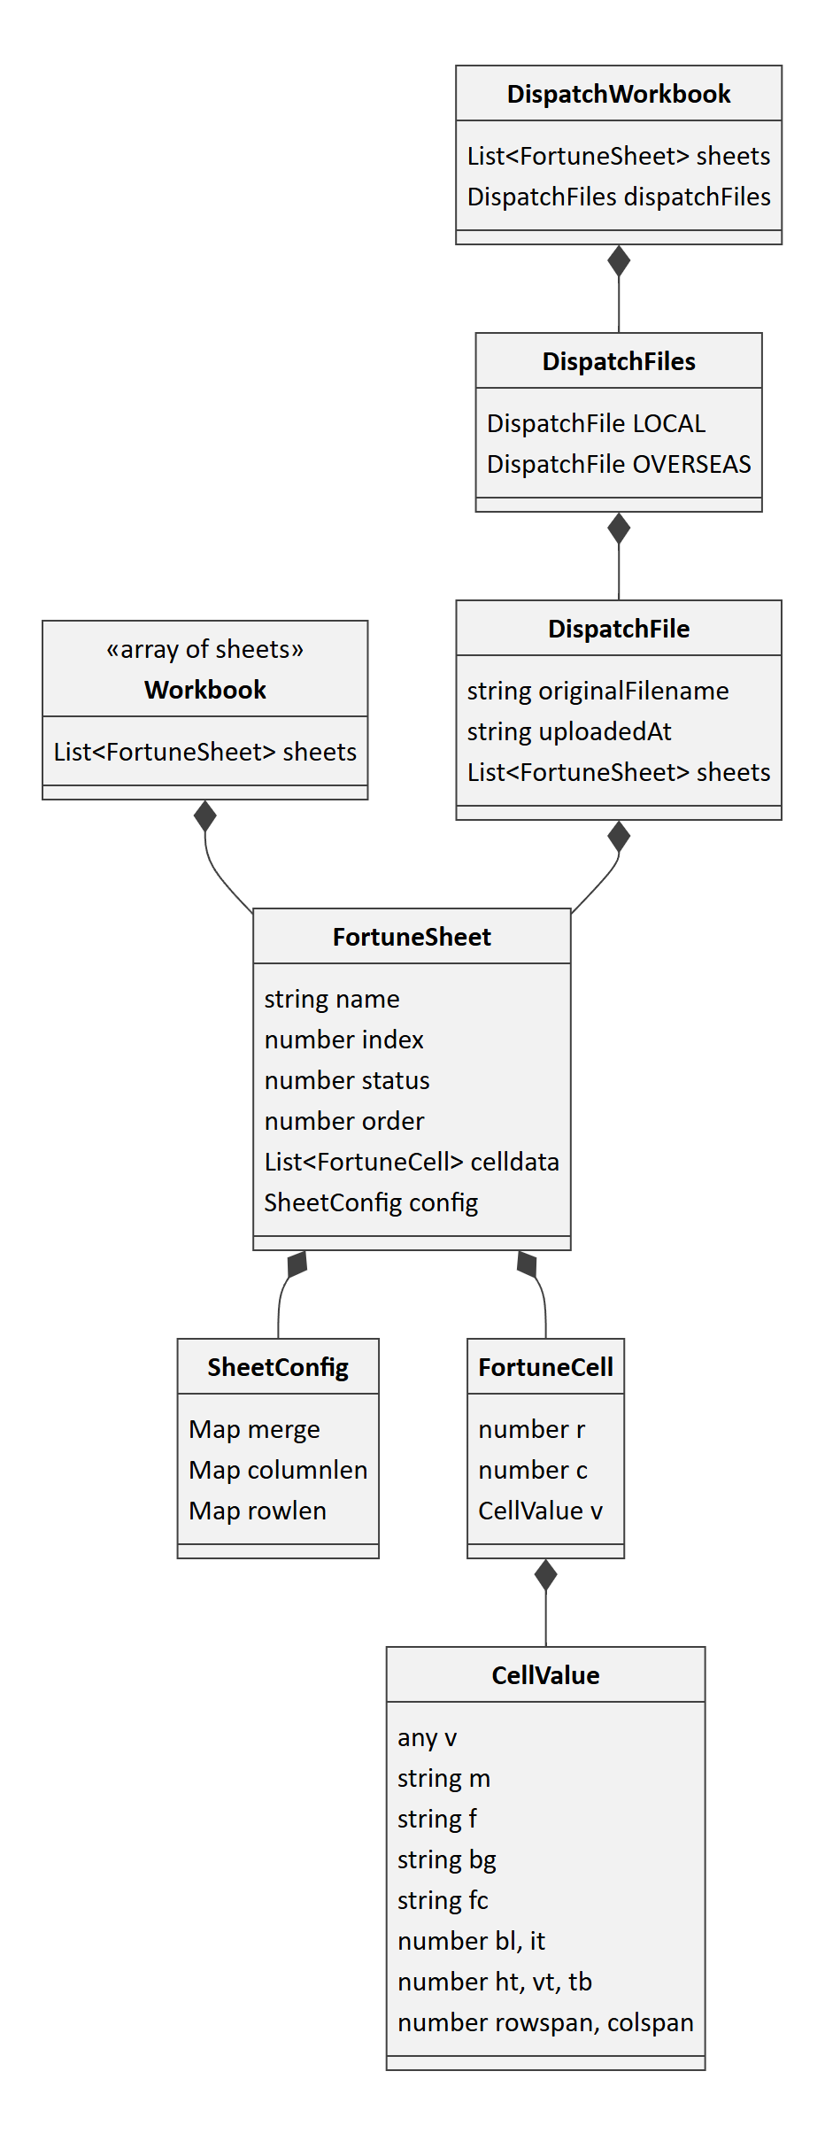
Figure 2: The workbook model stored in FileVersion.parsedWorkbook

3.1 FortuneSheet, one worksheet
Field | Type | What it means
name | Text | The sheet's name. For Dispatch, "Local - " or "Overseas - " is added in front
index and order | Number | The position of the sheet, counting from 0
status | Number | 1 for the first sheet and 0 for the others
celldata | A list of FortuneCell | Every cell that is not empty
config.merge | A map from "row_col" to { r, c, rs, cs } | Merged ranges, given by the top-left cell, the number of rows and the number of columns
config.columnlen | A map from column to number | Column widths in pixels (Excel's width multiplied by 8)
config.rowlen | A map from row to number | Row heights in pixels (Excel's height multiplied by 1.33)

3.2 FortuneCell and CellValue, one cell
Field | Type | What it means
r and c | Number | The row and column, counting from 0
v.v | Text, number, true or false, or a date | The value itself. For a formula, this is its calculated result. Every cell inside a merge repeats the top-left value
v.m | Text | The value as display text
v.f | Text | The formula, if there is one, such as =SUM(B2:B9)
v.bg | Text | The fill colour in hex, with theme colours worked out including their tint
v.fc | Text | The font colour in hex
v.bl and v.it | 0 or 1 | Bold and italic
v.ht | 0, 1 or 2 | Horizontal alignment: centre, left or right
v.vt | 0, 1 or 2 | Vertical alignment: middle, top or bottom
v.tb | 0 or 2 | 2 when the text wraps
v.rowspan and v.colspan | Number | The size of the merge, recorded only on its top-left cell

3.3 The Dispatch workbook
Field | Type | What it means
sheets | A list of FortuneSheet | The sheets of both files together, for anything that just needs a simple list
dispatchFiles.LOCAL and dispatchFiles.OVERSEAS | { originalFilename, uploadedAt, sheets } | Each file on its own, so that an upload replaces only its own part

4. Database tables
Supabase holds eleven tables. Version 1.0 uses six of them. The other five are defined but not written to, because the data they were meant for is kept inside each Mr11Run instead. In the diagrams, "DOUBLE" stands for DOUBLE PRECISION and "TEXT_ARRAY" for TEXT[].
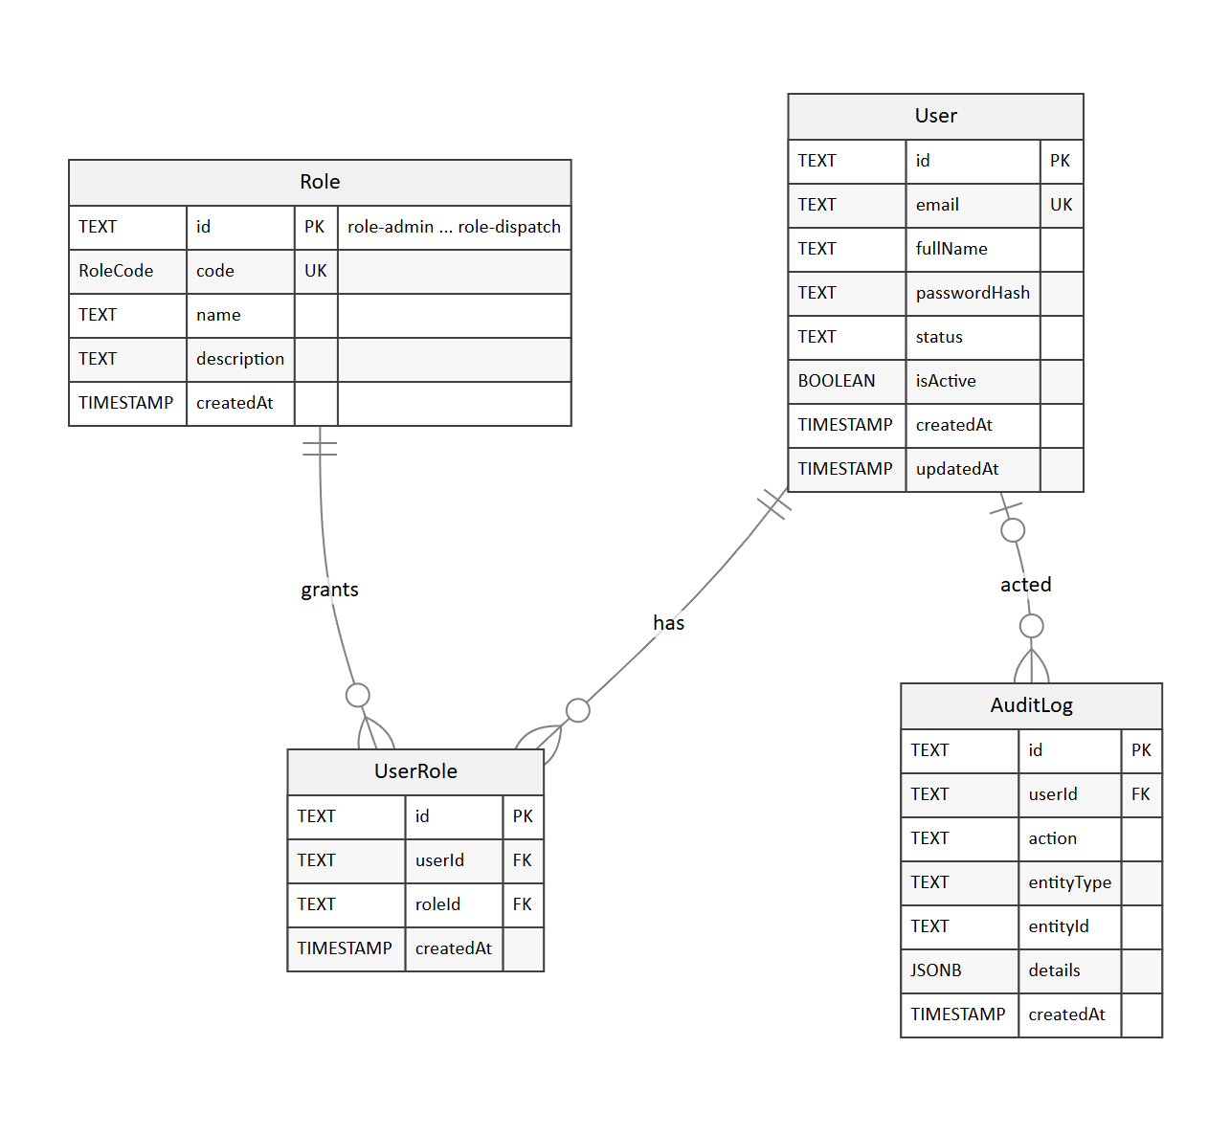
Figure 3: Accounts, made up of users, roles and the audit log
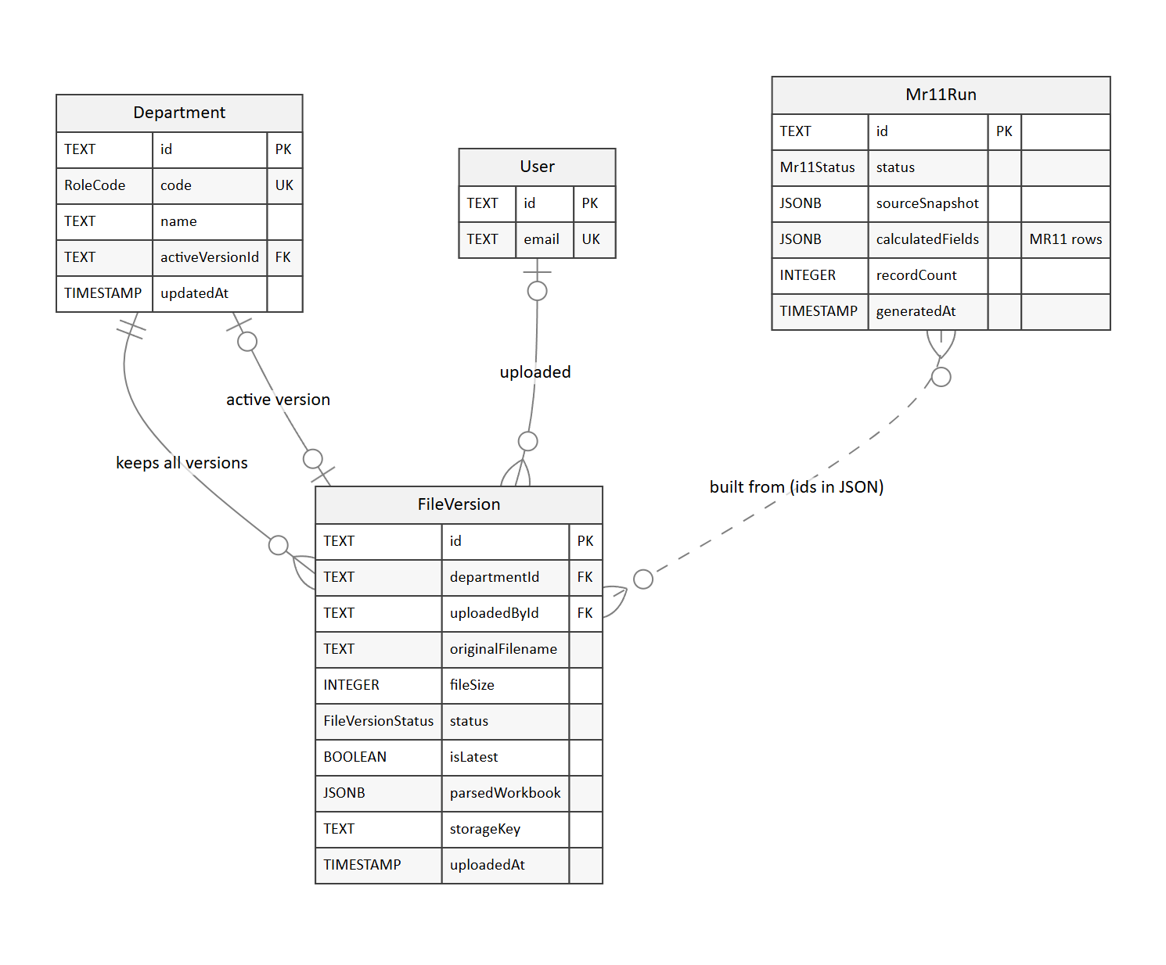
Figure 4: Workbooks and MR11 runs
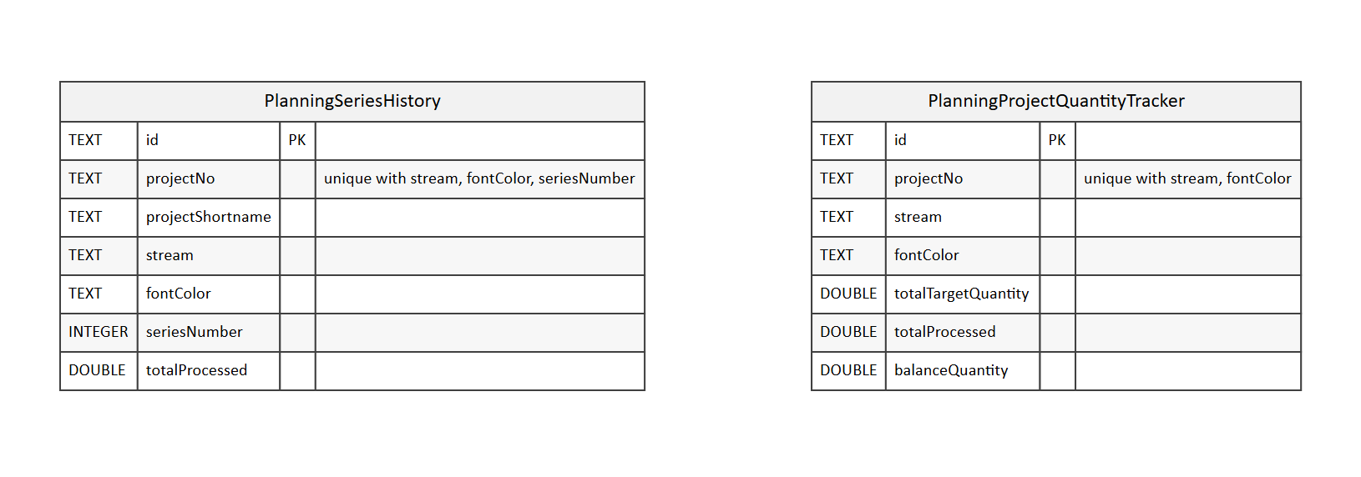
Figure 5: History tables that are defined but not written to in version 1.0 (part 1)
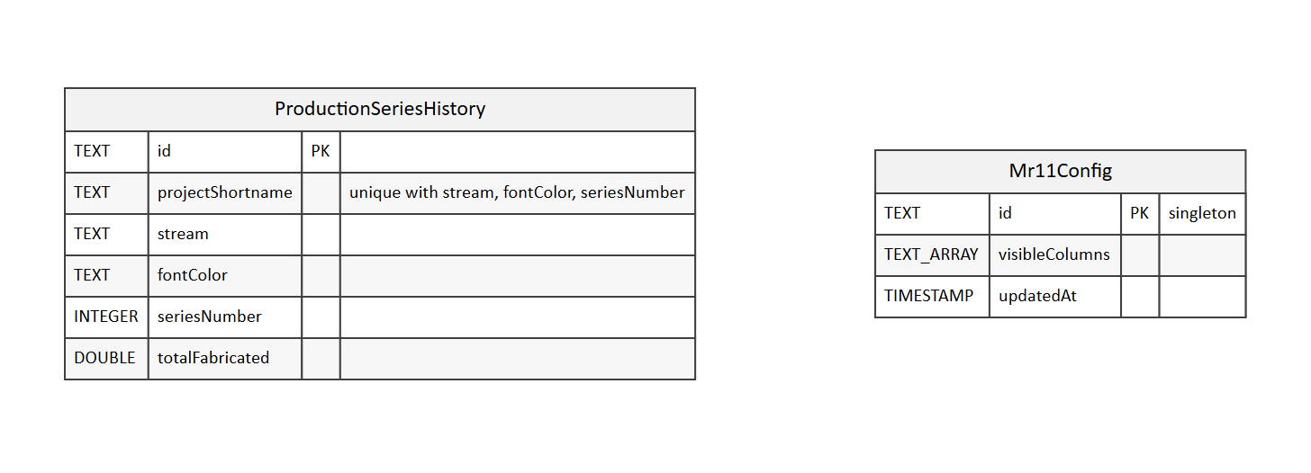
Figure 6: History tables that are defined but not written to in version 1.0 (part 2)
Table | What it holds | It grows with | Used in version 1.0
User | The people who can sign in | New accounts | Yes
Role | The nine roles, with fixed ids | Never | Yes
UserRole | Which user has which role | Role changes | Yes
Department | The seven departments and their active workbook | Never | Yes
FileVersion | Every workbook ever uploaded | Every upload | Yes
Mr11Run | Every build of the MR11 | Every upload, sync, row delete or restore | Yes
AuditLog | Records of uploads | Nothing | No; the log is kept in memory
Mr11Config | The visible-column setting | Nothing | No; it is only seeded
PlanningSeriesHistory, PlanningProjectQuantityTracker and ProductionSeriesHistory | Series history | Nothing | No; this is kept in Mr11Run.sourceSnapshot

The enumerated types are RoleCode (ADMIN, CEO, BD, FINANCE, SHELLPLAN, DESIGN, PLANNING, PRODUCTION and DISPATCH), Mr11Status (EMPTY, PARTIAL, READY and FAILED) and FileVersionStatus (UPLOADING, PROCESSING, READY and FAILED).

5. Extracted rows, used while the MR11 is built
The engine's sheetToRecordsWithStyles() function reads the first sheet of a workbook into rows. It takes the headers from the top rows, brings up sub-headers that sit under a repeated group header such as "Payment terms", and renames duplicate headers to "Type", "Type 2", "Type 3" and so on.
Field | Type | What it means
data | A map from header to value | The row's values, looked up by header name
fontColor | Text | The row's font colour, used to match blocks across departments
fillColor | Text | The row's fill colour
rawCells | A map from column to value | The values by column position, used to drop BD rows that are empty
mergedCopyHeaders | A list of text | The headers whose value was copied from a merged cell, so that totals count it only once
dispatchPart | LOCAL or OVERSEAS | For Dispatch only, which file the row came from

6. The MR11 run and its rows
Each build of the MR11 is saved as one Mr11Run. Its rows are the schedule that users see, and its snapshot carries forward everything the next build needs to know.
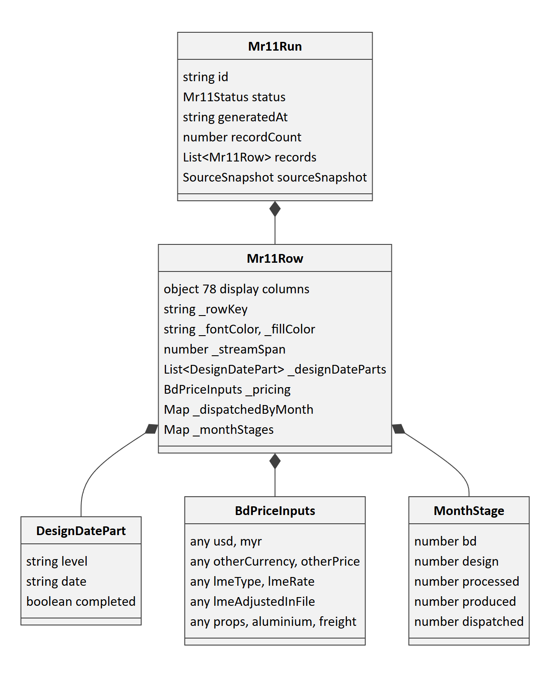
Figure 7: Mr11Run, its rows and each row's internal fields

6.1 An MR11 row
Each row is a JSON object holding the 78 columns shown on screen (listed with their types in Appendix A.5 of the System Architecture Document), plus some internal fields whose names start with an underscore.
Internal field | Type | What it means
_rowKey | Text | Identifies the row from one build to the next, using its short name, stream, font, fill and product type. It is used to delete and restore rows
_fontColor and _fillColor | Text | The BD row's colours, used on screen and in the export
_streamSpan | Number | On the first row of a block, how many rows share its Shell Plan and Design cells; 0 on the rows that follow
_designDateParts | A list of DesignDatePart | The completion dates for each level, as { level, date, completed }
_pricing | BdPriceInputs | BD's price inputs: usd, myr, otherCurrency, otherPrice, lmeType, lmeRate, lmeAdjustedInFile, props, aluminium and freight
_priceNote | Text | Explains a price that couldn't be converted, for example because the currency wasn't recognised
_dispatchedByMonth | A map from month (such as "2026-10") to m² | The m² dispatched in each month
_dispatchFile | LOCAL or OVERSEAS | Which Dispatch file the row uses
_monthStages | A map from month (such as "Oct-26") to MonthStage | The CEO pipeline for each month: bd, design, processed, produced and dispatched, all in m²
_designOnly | True or false | True for Re-Design Only rows, which are in blue font
_designDate, _dispatchedDate and _atdDate | Text holding a date | Single dates that the CEO Executive Hub uses to group figures by month

6.2 The source snapshot
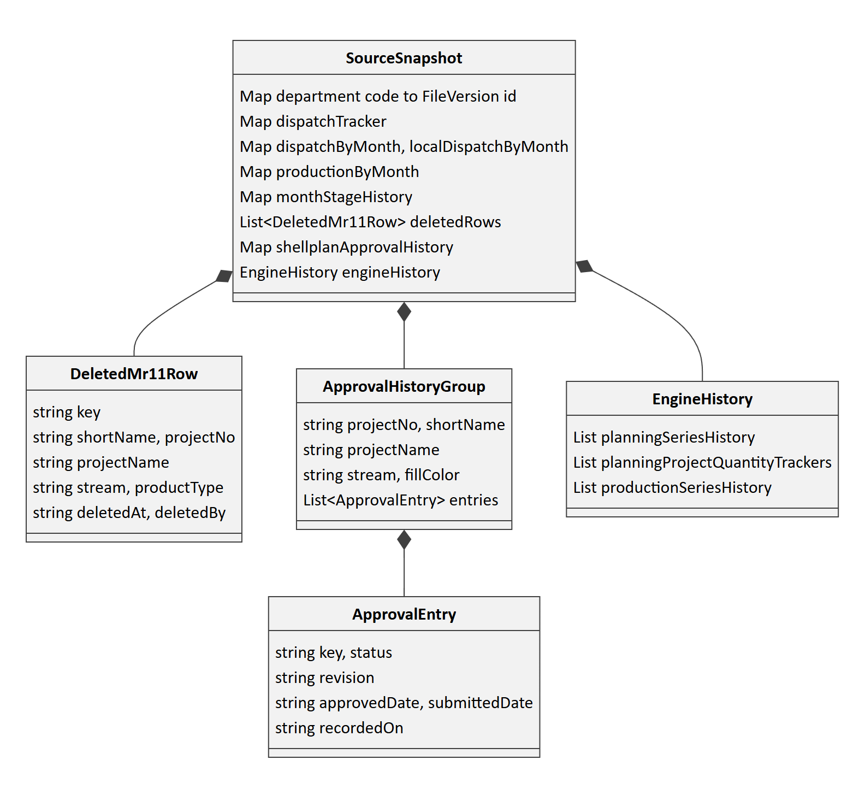
Figure 8: The source snapshot carried from one build to the next
Field | Type | What it means
BD, FINANCE, DESIGN and the other department codes | Text | The FileVersion id of the workbook each department contributed. If a newer upload exists, the run is out of date
dispatchTracker | A map from row key to { quantity, date } | The last Total Dispatch, and the date it changed
dispatchByMonth | A map from row key to a map from month to m² | The Overseas Total Dispatch at the last upload of each month
localDispatchByMonth | A map from row key to a map from month to m² | The Local m² dispatched in each month, kept after the monthly file resets
productionByMonth | A map from row key to a map from month to m² | The m² produced in each month, kept after the monthly file resets
monthStageHistory | A map from row key to a map from month to { design, processed } | The Design and Processed forecast for each month, as it last stood
deletedRows | A list of DeletedMr11Row | The rows an administrator removed, with their key, names, stream, product type, deletedAt and deletedBy
shellplanApprovalHistory | A map from stream key to ApprovalHistoryGroup | Every Approved and Reapprove seen so far, with its revision and dates
engineHistory | EngineHistory | The Planning series, the Planning quantity trackers and the Production series

7. API models
Every response uses the same envelope: { success, data } when it works, and { success: false, error: { code, message } } when it doesn't.
Model | Fields | Returned by
LoginResponse | token, and user { id, email, fullName, roles[], usingDefaultPassword } | POST /api/auth/login
CurrentUser | user { id, email, fullName, roles[] } | GET /api/auth/me
Department | id, code, name, description, activeVersionId, and activeVersion { id, originalFilename, status, uploadedAt, parsedWorkbook, uploadedBy } | GET /api/departments and /api/departments/:code
Mr11Response | run, fxRate, currencyRates[], lmePrice, visibleColumns, orderedHeaders, headerGroups, numberFormats, columnDepartments and departmentColors | GET /api/mr11
FxRate | rate, source, asOf and live | Part of Mr11Response
CurrencyRate | code, rate, inBd and source | Part of Mr11Response
LmePrice | cash, threeMonth, previousCash, asOf, source and live, in USD per tonne | Part of Mr11Response
HeaderGroup | label, and columns [{ key, label }] | Part of Mr11Response
PlanningSeries | projectNo, projectShortname, projectName, stream, fontColor, seriesNumber, totalProcessed, totalQuantity and closingDate | GET /api/mr11/planning-series
ProductionSeries | projectShortname, projectNo, projectName, stream, fontColor, seriesNumber and totalProduced | GET /api/mr11/production-series
ApprovalHistoryRow | projectNo, shortName, projectName, stream, fillColor, status, revision, approvedDate, submittedDate and recordedOn | GET /api/mr11/shellplan-history
DispatchMonthlyRow | shortName, projectNo, stream, productType, file, fontColor, fillColor, totalDispatch and months | GET /api/mr11/dispatch-monthly
DeletedRow | key, shortName, projectNo, projectName, stream, productType, deletedAt and deletedBy | GET /api/mr11/deleted-rows
AdminUser | id, email, fullName, createdAt and roles[] | GET /api/admin/users

8. Browser state

8.1 Who is signed in (the Zustand store in src/store/auth.store.ts)
Field | Type | What it means
token | Text, or nothing | The session token (a JWT)
user | An object, or nothing | { id, email, fullName, roles[] }
usingDefaultPassword | True or false | True until the user changes the default password

8.2 What the browser remembers in localStorage
Key | Type | Set by | What it remembers
mfe_token | Text | The sign-in store | The session token, sent with every API call
mfe_user | JSON | The sign-in store | The signed-in user
mfe_default_password | "1" | The sign-in store | That the default password is still in use
sidebar.open | True or false | The sidebar | Whether the sidebar is expanded or collapsed
mr11.zoom | Number | The MR11 page | The table's zoom level, from 20% to 135%
mr11.sidePanelOpen | True or false | The MR11 page | Whether the Options panel is showing
mr11.hiddenColumnGroups | A list of text | The MR11 page | Which column groups are hidden
mr11.showRatesStrip | True or false | The MR11 page | Whether the market cards are showing
zoom.PLANNING, zoom.PRODUCTION and the other department codes | Number | The department pages | The sheet's zoom level on each department page
design.showApprovalHistory | True or false | The Shell Plan & Design page | Whether the approval history is showing
dispatch.part | LOCAL or OVERSEAS | The Dispatch page | Which Dispatch file is shown
dispatch.showMonthly | True or false | The Dispatch page | Whether the monthly dispatch table is showing

The MR11 filters and the search box are only kept while the page is open.

9. The in-memory store on the server
Each server instance keeps a working copy of the data in server/db/prisma.ts. It uses the same model names as the database, so the code reads as if it were using Prisma.
Collection | Key | Where its data comes from
users and userRoles | id | The Supabase User and UserRole tables (the seed accounts are used until these are loaded)
roles | id, such as role-admin | Built into the code
departments | id, such as dept-bd | Built into the code, with activeVersionId set from Supabase
fileVersions | id | The active versions in the Supabase FileVersion table
mr11Runs | A list | Builds made on this instance, or the latest one from Supabase
planningSeriesHistory | projectNo_stream_fontColor_seriesNumber | Mr11Run.sourceSnapshot.engineHistory
planningProjectQuantityTrackers | projectNo_stream_fontColor | Mr11Run.sourceSnapshot.engineHistory
productionSeriesHistory | projectShortname_stream_fontColor_seriesNumber | Mr11Run.sourceSnapshot.engineHistory
auditLogs and mr11Config | Not applicable | Memory only

10. Configuration models (server/config/mr11.config.ts)
Model | Fields | What it means
ColumnMapping | target, sourceDept, sourceColumn, type (string, number or date), exact and aliases | Which department column fills an MR11 column. "exact" means the whole header must match, and the aliases are older header names that are also accepted
ORDERED_HEADER_LIST | A list of text | The 78 MR11 columns, in the order they are shown
MR11_HEADER_GROUPS | A list of HeaderGroup | The columns that sit under a shared top header (Payment terms)
MR11_NUMBER_FORMATS | A map from column to number of decimal places | Fixed decimal places, such as 3 for LME Rate and 2 for payment amounts
MR11_USD_AMOUNT_COLUMNS | A list of text | The columns shown with a dollar sign
MR11_COLUMN_DEPARTMENTS | A map from column to department | Which department each column comes from, used for highlighting
MR11_DEPARTMENT_COLORS | A map from department to hex colour | Each department's highlight colour
MR11_SOURCE_KEY_MAP | A map from department to header names | The headers that identify the project in each department's file

